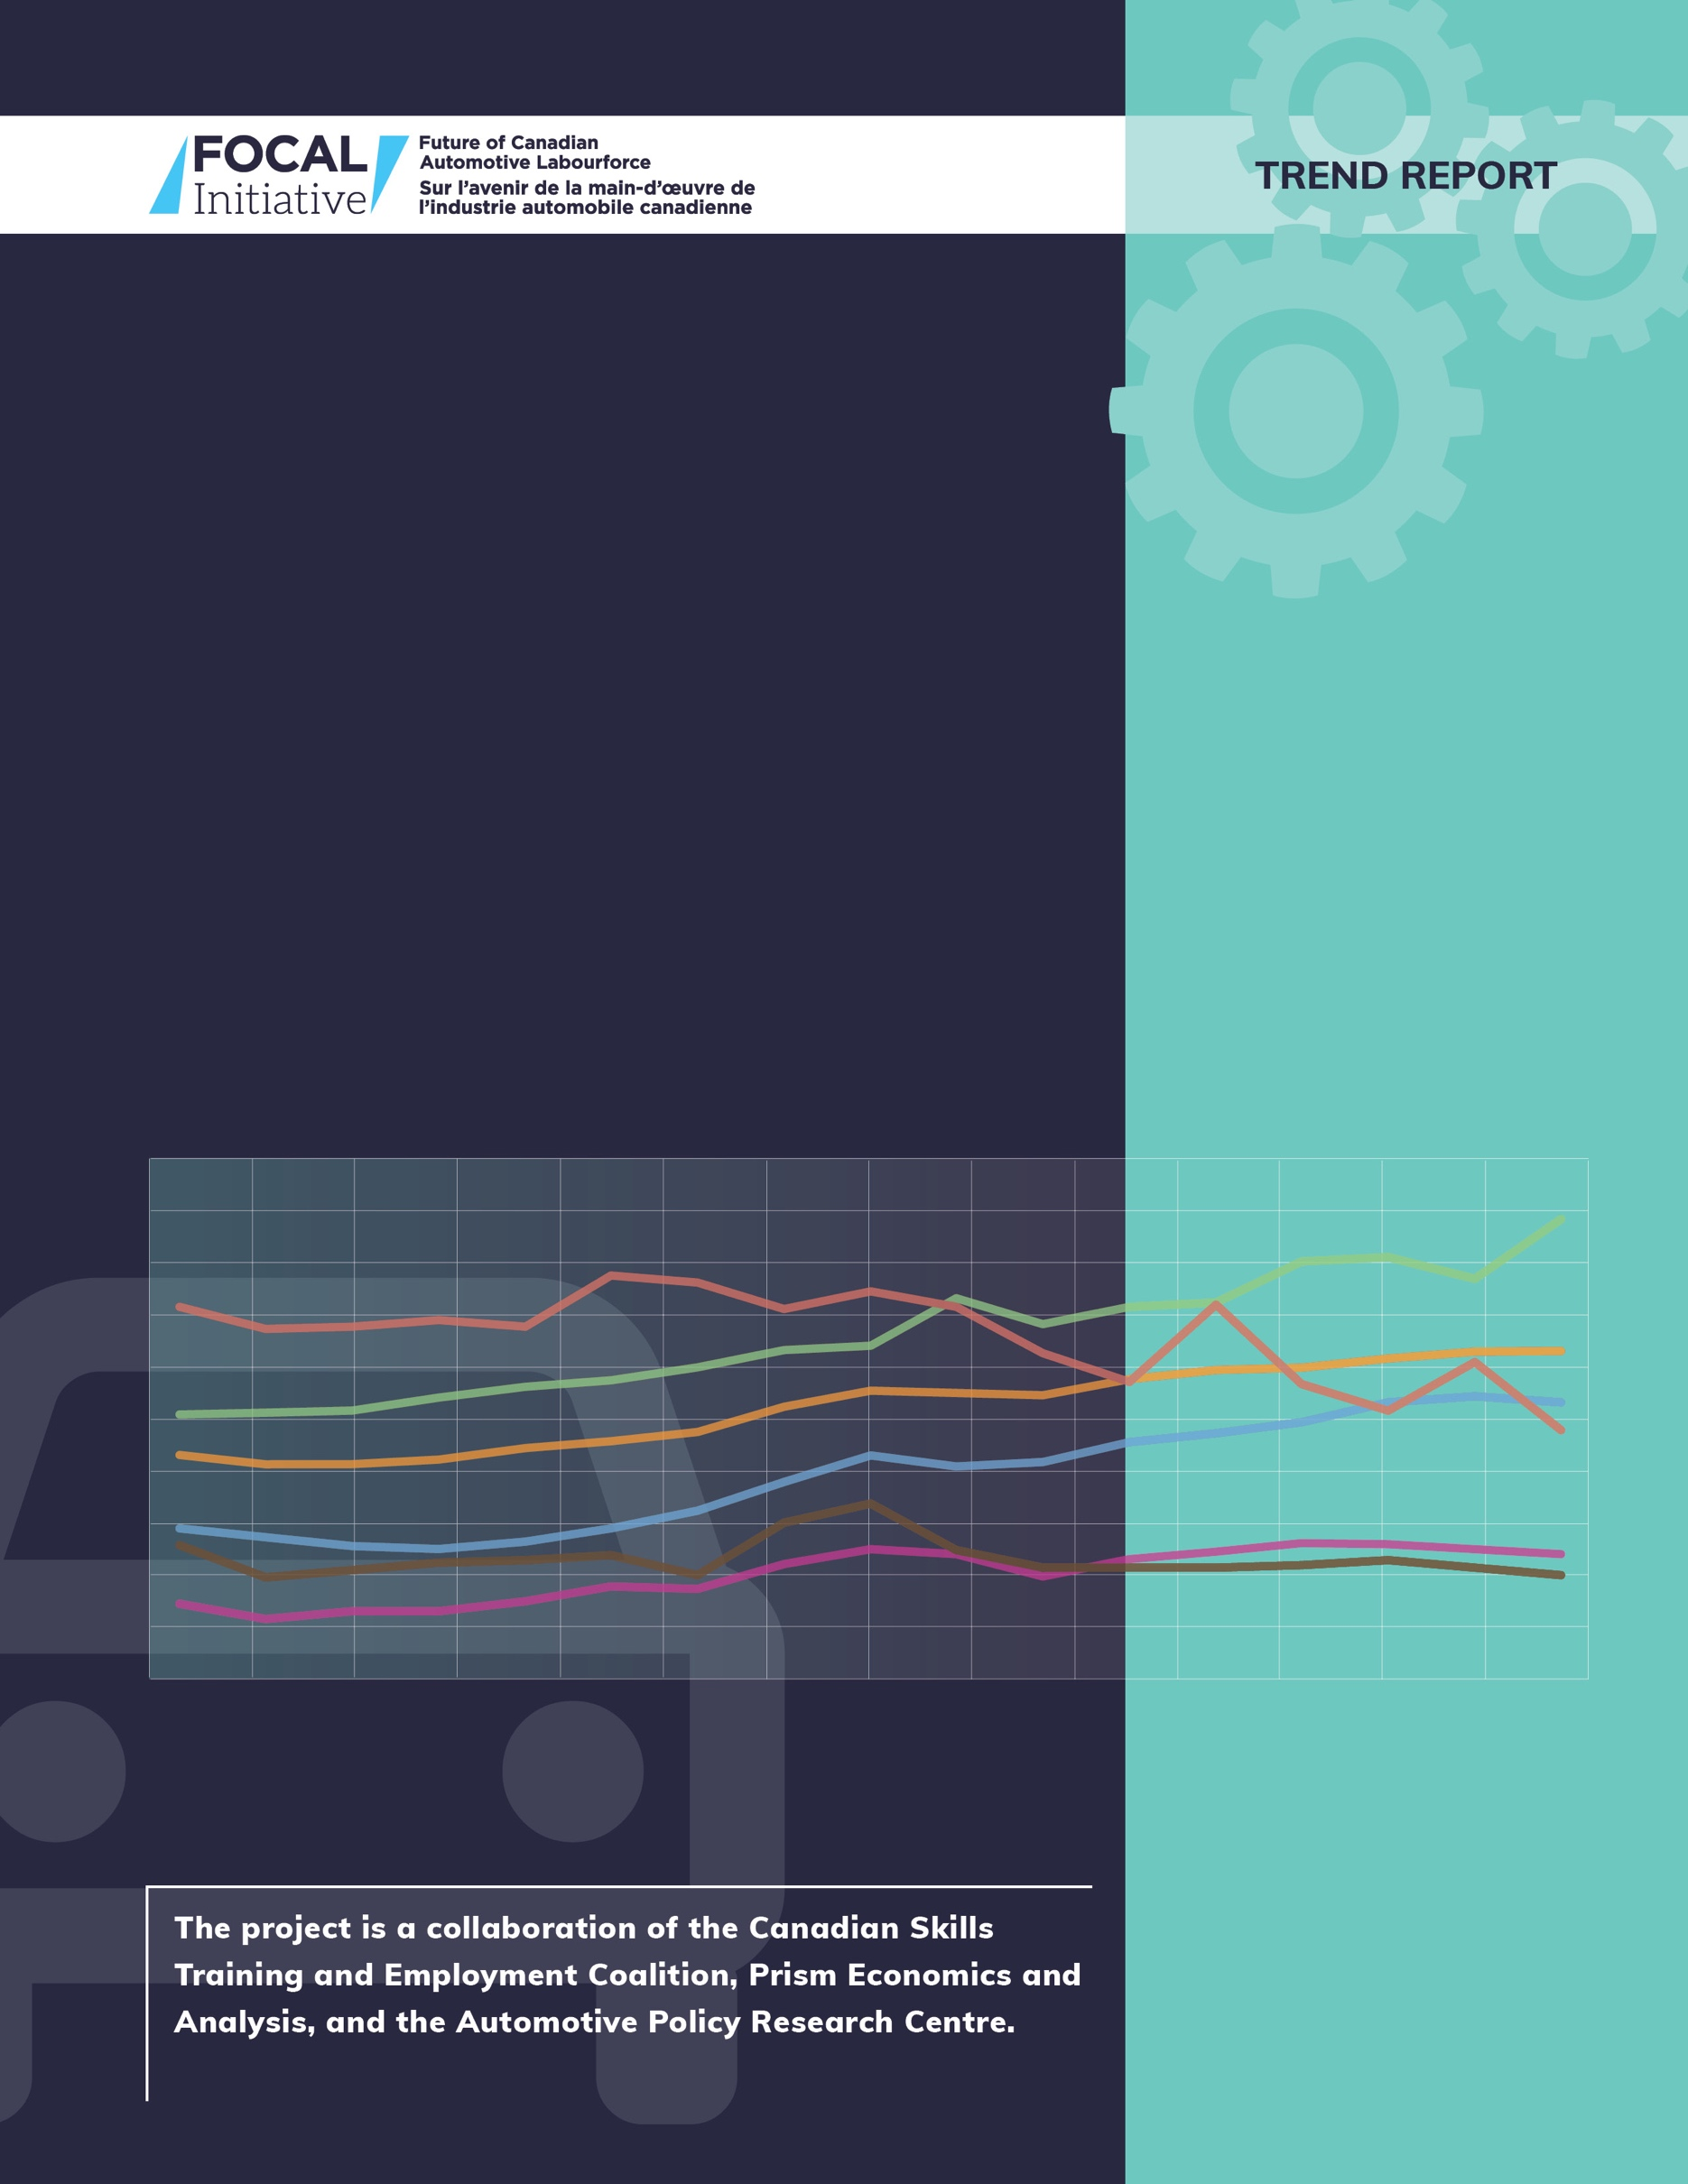
Recruitment and Retention Issues: Input from Automotive Production Employers in Small and Large Population Centres in Ontario

futureautolabourforce.ca
October, 2021
AUTOMOTIVE
INDUSTRY LABOUR MARKET ANALYSIS

THIS PAPER was prepared for the Auto Labour Market Information (LMI) Project, now known as the Future of Canadian Automotive Labourforce (FOCAL) Initiative.

The goal of the project is to help stakeholders better understand the automotive labour market. The Project will create industry-validated, regional, occupational supply and demand analyses and forecasts and skill profiles for skilled trades and other key skilled occupations in the broader automotive sector including vehicle assemblers, parts manufacturers and technology companies that supply the industry. The project will also examine various labour market trends in the sector and facilitate discussions among stakeholders about how to address any forecasted skills shortages and other labour market challenges. The planned outcome of the project is enhanced regional labour market information that will support colleges, employers, policy makers and other stakeholders in taking practical steps to address skills shortages and other labour market challenges in the automotive sector.

This project is funded by the Government of Canada’s Sectoral Initiatives Program. The opinions and interpretations in this publication are those of the author(s) and do not necessarily reflect those of the Government of Canada.

(FOCAL) Initiative, futureautolabourforce.ca
Canadian Skills Training and Employment Coalition, cstec.ca
Prism Economics and Analysis, prismeconomics.com
Automotive Policy Research Centre, automotivepolicy.ca

October, 2021

iNTRODUCTION
During the term of the FOCAL Initiative, we have held consultations and engagements with automotive production sector employers and other stakeholders across Canada. Notable among these was a series of five (5) in-person regional meetings in Ontario in the fall of 2019 with thirty (30)employers, six (6) one-on-one key informant interviews by telephone in the fall of 2019 with more employers in Ontario and Manitoba, a second series of five (5) regional meetings (held on-line due to the pandemic) in the spring of 2021 with thirty seven (37) automotive production sector employers in Ontario, and an Ontario wide webinar in the fall of 2021 with a wide range of sector stakeholders including eighteen (18) automotive production employers. In fact, over the three-year span of the FOCAL Initiative, our team has had over 600 interactions with automotive production employers and other key community, government, educational institution, and industry association stakeholders.
During our consultations, representatives of several small and medium-sized employers (SMEs) in the Ontario’s automotive production sector with operations in rural/smaller population centres indicated their views that the recruitment and retention challenges by their company’s operations in these smaller centres differed from those facing employers in larger population centres. Some employer representatives indicated the recruitment challenge is greater in rural /smaller population centres.
FOCAL considers it important to understand both the commonalities and differences among these concerns and the range of issues covered by FOCAL’s other research. Therefore, during the late spring and early summer of 2021 FOCAL staff held telephone interviews with seven (7) automotive production sector SMEs in rural/smaller population centres in Ontario. FOCAL staff also held three (3) interviews with automotive production sector SMEs in urban/larger population centres in Ontario.
This paper is based on interviews with both human resources and operational managers of those ten (10) plants. It examines some of the differences in respect of urban and rural employment issues which affect human resources recruitment and retention. It summarizes the feedback from these interviews and blends that feedback with other FOCAL Initiative work around key labour market issues in Canada’s automotive production sector.
Balancing production mandates and employment
Employer representatives noted that automotive production sector employers face a complex web of factors which impact their employment requirements and rates of technology adoption. The same range of factors also affects the attitudes and choices of potential jobseekers, especially those who are youth.
Automotive production employers scale their deployment of labour and automation in relation to production requirements. At the same time, price competition between original equipment manufacturers (OEMs) or vehicle assemblers, drives choices throughout the supply chain. These factors, plus low profit margins for parts makers on individual pieces, drive SMEs to place a strong focus on cost control over the time horizon required to justify capital investments for production. Automotive parts companies with relatively lower added value generate lower per piece margins and thus require high volume runs to make production profitable. Therefore, in these lower value-added contexts, automation is justifiable only for longer period production runs due to the need to recoup capital costs.
Due to these and other issues specific to the automotive production sector, automotive parts makers face barriers against increasing their compensation and benefits to attract more and better candidates to fill job openings. Earlier FOCAL research into wages in Canada’s automotive production sector sets out this context in substantial detail and provides measures of declining real wages for employees in vehicle manufacturing and in parts manufacturing since 2001.

Description of employers interviewed
Interviewees were human resources and operational staff of ten (10) Ontario automotive parts production and related plants engaged in a range of production activities including fabrication, processing, assembly, machining, tooling, and parts production. Some of these operations are branch plants of larger and in some cases multinational companies, while others are smaller, owner-operated workplaces. Below is a non-identifying list of the seven (7) companies interviewed located in definably rural / smaller population locations and the three (3) companies interviewed located in definably urban / larger population locations.
Rural:
- automotive parts manufacturer, southwestern Ontario: approximately 50 employees making metal components for automotive production

- automotive parts manufacturer, eastern Ontario: approximately 20 employees making injection mold composites for automotive production

- automotive parts and other sectoral parts manufacturer, southwestern Ontario: approximately 50 employees making metal components for automotive production

- automotive parts and other sectoral parts manufacturer, southwestern Ontario: approximately 250 people employees making metal components for the automotive, energy, medical, transportation, and other industries

- automotive parts manufacturer, southwestern Ontario: approximately 80 employees in a tube bending/welding assembly facility

- automotive parts manufacturer, southcentral Ontario: approximately 60 employees in the manufacturing of tubular products for the automotive industry
Urban:
- tooling and die manufacturer, southcentral Ontario: approximately 15 employees building moulds and dies for the automotive industry

- automotive components manufacturer, Greater Toronto Area: approximately 220 employees making molded materials and composite products for the automotive industry

- automotive parts manufacturer, Greater Toronto Area: approximately 25 employees in manufacturing and service of instrumentation equipment for automotive and other industries

Demographic issues
Historically, the demographic compositions of workforces of automotive production sector employers in rural / smaller population locations have been less diverse than those in automotive production sector workforces in urban / larger population centres, as new immigrants to Canada have tended to locate in larger urban areas upon arrival. Indeed, as revealed in other FOCAL research, the immigrant labour force share in automotive parts production in the Greater Toronto Hamilton Area (GTHA) is 60%, while the corresponding proportion for Ontario is 40% .
However, several representatives of employers in rural/smaller population centres who were interviewed in the summer of 2021 reported that these trends appear to have moderated in recent years. They reported a trend of outmigration from urban centres to their rural/smaller population communities by previously established immigrant families seeking lower housing costs, reduced traffic congestion, and other amenities available in these smaller communities. Several employers also noted that the pandemic has intensified migration out of urban/larger population centres into rural/smaller population centres, thus alleviating some of the human resources challenges in these rural/smaller population centres.
Further, several employers in rural/smaller population centres reported that the children of these previously established immigrant families who relocate to their communities are increasingly choosing to continue to reside in and seek career opportunities in these smaller communities. Several employers reported that this trend may assist them in recruiting new employees in managerial, technical, and professional occupations.
Historically, automotive production employers located in rural/smaller population centres have tended to have a comparatively polarized profile in respect of the age of their workforces, with significant numbers of relatively younger employees in entry level production positions and, at the same time, relatively large numbers of senior employees aged over 50 in senior production and supervisory positions. In urban / larger population centres, employers have been able to rely on a more balanced age distribution throughout all positions.
This feedback from employers accords with one of the main points in FOCAL’s trend report on youth employment issues in the automotive production sector, which stated: “In Ontario, growing disparities in the age distributions of working age populations between larger communities and smaller, more rural communities will likely provide additional pressures on automotive employers in those smaller communities”.
As well, representatives of automotive manufacturers located in rural/smaller population locations indicated that their operations have tended historically to provide higher levels of compensation and benefits than were available from other employers in such communities and to thereby provide attractive options to young jobseekers in the region. But a number of employers in these rural/smaller population communities reported that recent trends indicate that younger residents are increasingly departing to seek postsecondary opportunities elsewhere, reducing the likelihood of them returning to their home communities.
Recruitment practices and challenges
Employers were canvassed as to their preferred recruitment practices and about their success with those different practices.
All employers interviewed, regardless of location, indicated the use of a wide variety of initiatives to publicize and advertise job openings such as online job board postings, social media, engagement with educational facilities, hiring incentives, ‘word-of-mouth’, and occasional use of hiring agencies/consultants.
All employers reported an increasingly strong reliance of their human resources departments on the use of online postings and other online recruitment sourcing tools, including but not limited to social media employment options such as LinkedIn Jobs, Indeed, and Monster. But some employers in rural / smaller population centres offered opinions that these online tools were likely more useful in urban / larger population centres.
Unsurprisingly, employers in rural / smaller population centres reported fewer challenges with what one employer termed ‘job-jumping’, the phenomenon in which employees frequently depart jobs to seek other employment opportunities located nearby in the same community. Employers in rural/smaller population centres reported that the relative absence of other geographically proximate employment alternatives provided their operations with a greater level of employment stability, resulting in workforces characterized by longer job tenure, greater experience, and greater age. While rural/smaller population centres understandably lack the range of employment alternatives available in larger centres, it is also evident that as a percentage of overall employment, manufacturing plays a more important role in small-town and rural communities than it does in larger urban centres.
Several employers located in rural/smaller population centres indicated that they had made some modest recent enhancements in employee compensation and benefit packages meant specifically to reduce the chances of employees departing for other employment opportunities in urban / larger population centres.
Employers indicated, expectedly, that short term increases in production are often addressed by adding overtime labour. If production increases stretch out for such a length of time as to necessitate new hiring, employers generally reported that their least preferred option is the use of temporary employment agencies. Employers suggested that temporary employment agencies entail costs without the guarantee of quality candidate recruitment such that in both rural/smaller population centres and in urban/larger population centres employers used temporary employment agencies as a last resort.

Recruitment Successes
When filling entry-level positions in production, all companies, whether located in rural/smaller population centres or urban/larger population centres, reported much less reliance on referrals, networking, and professional recommendations. But several employers in rural/smaller population centres referred positively to recruitment successes that have been built by working through and with the support of immigrant supporting organizations, Indigenous and women’s groups, and other community-based groups in order to strategically promote job openings and to take advantage of the internal referral networks and links to community leaders that can be accessed by working cooperatively with these groups and organizations.
All employers placed a focus on building their current workforces through internal training and up-skilling, consideration of micro-credentialing, and some reported engagement in cooperative projects with training institutions such as geographically proximate colleges.
Several employers in rural/smaller population centres reported that lengthy commuting distances are a significant barrier to attracting employees on a co-op/intern basis or as apprentices. Generally, employers in these communities noted that new hires with their own personal vehicles are willing to engage in commutes of no longer than an hour. Of course, the relative lack of public transit options to/from these communities, as compared to urban/larger population centres provides a further limitation on labour supply.
However, some employers in rural/smaller population centres did report what they interpret to be some success in attracting higher-level, professional candidates for more senior positions who chose to relocate from urban/larger population centres to take employment in these smaller communities. Employers indicated that these sorts of new hires are often focused on career aspirations towards senior management positions and are therefore willing to locate to rural/smaller population communities and to intentionally trade off higher salaries that would be available in urban areas for the more diverse work experiences, less cluttered promotional paths offered by employers in rural/smaller population communities and potential ownership/equity opportunities.
FOCAL’s previous research into immigrant labour in the automotive production sector indicates that among Ontario regions, the proportion of immigrant labour in the GTHA is significantly higher in the category of engineering, technical, and managerial occupations than it is in the category of supervisory and production occupations or in the category of skilled trades occupations. Therefore, opportunities may exist for employers in rural/smaller population centres to attract the relocation into their communities of immigrants who are current holders of engineering, technical, and managerial jobs in urban/larger population centres.

Hiring challenges - specific occupations
Recruiting for skilled trades occupations continue to be a significant challenge for all employers interviewed. FOCAL’s occupational forecasts indicate significant hiring gaps for skilled trades in all regions of Ontario. Employers reported similar recruitment challenges for some of the more sophisticated technical occupations in production machinery operation.
Employers also indicated concerns about seeking a balance between training young skilled trades apprentices from within the company and hiring experienced tradespeople from outside the company. The length of time to complete apprenticeships and the lack of certainty with respect to completion rates both serve to increase the motivation to consider outside hirings, but that comes at the expense of higher compensation costs for seasoned skilled trades employees. The skilled trades hiring challenge was the same across employers interviewed for this paper both for rural/smaller population centred employers and for urban/larger population centred employers; all indicated concerns that there is insufficient supply.
Some employers indicated that increased automation and sophistication of some production machinery provides challenges to some existing skilled tradespeople in the electrical fields. The skills involved in diagnosing and repairing certain specialized equipment is increasingly outside of the scope of past training and experience of some existing skilled trades employees. This requires employers to then hire outside expertise to resolve some of these technological issues. One employer suggested that the relevant certification body needs to augment apprenticeship programs to include training of electricians in respect of these newer automation technologies.
For example, to respond to increased digitization and automation, employers perceive the need for new types of technical skills sets in respect of systems such as programmable logic controllers (PLCs), robotics, servo motors, IoT devices, artificial intelligence (AI), data analytics, ERP/EDI systems, etc.
Finally, employers reported that their response to the skilled trades labour shortage has been to increasingly develop internal hybrid skills models to cross train employees across multiple disciplines, specific to the employer’s unique needs.

Issues impacting hiring
Some employers expressed the sentiment that a substantial reason for their recruitment challenges is disinterest among younger workers to enter the automotive production sector. Employers in rural/smaller population centres expressed this concern more strongly than employers in urban/larger population centres. FOCAL’s trend report on youth employment issues in the automotive production sector provides background details, data, and other information related to this concern.
Some employers noted that recent increases in Ontario’s minimum wage may have some impact on labour supply on the basis that alternative employment possibilities that had previously been paying less than some entry level positions in the automotive production sector would now be paying a modestly higher wage rate. Some employers reported that they have implemented varying strategies to offset the impact of legislated wage changes in order not to experience a reduction in the quantity of job applicants. Some reported providing adjustments in terms and conditions of employment such as vacations, flexible work hours, and production incentives/bonuses.
As well, possible effects of the now more attractive minimum wage on labour supply and on turnover for automotive production employers in rural/smaller population centres may be mitigated due to the limited number of alternate employment opportunities available within a reasonable commuting distance.
Employers in urban/larger population centres indicate that youth employee retention is a more significant problem than recruitment. The range of other job opportunities near automotive production employers in urban/larger population centres provides more options for “job jumping”.
Employers in rural/smaller population centres also noted concerns in their communities about limited housing supply and higher costs related to housing have been exacerbated by urban dwellers, motivated by pandemic issues, relocating to these communities over the last 18 months.

Policy recommendations from employers
The companies interviewed had a range of recommendations. They are presented here in general terms and are not meant to indicate recommendations from FOCAL:
- Employers in both rural/smaller population centres employers and urban/larger population centres indicated support for the continuation of government incentives for employers to hire co-op placements, interns, and support of apprenticeship programs.

- Employers in both types of regions also provided positive reviews of government incentives to promote skills training and upscaling of current employees.

- Employers in both types of regions considered retention to be of paramount importance in maintaining a productive and sustainable workforce, and they therefore suggested government consider options to incentivize individual workers to remain employed by company for a minimum period of time. This incentive could come in the form of a tax incentive or other form of benefit.

- Employers in rural/smaller population centres recommended that municipal and regional governments in these regions strategize and cooperate more effectively with provincial and federal governments to create incentives to attract new employees to their regions.

- Employers in rural/smaller population centres also expressed support for more federal and provincial assistance in investments for housing and infrastructure to support migration from urban/larger population centres.

References
Telephone interviews with 10 automotive production related employers, Summer 2021

“Youth Employment in Canada's Automotive Manufacturing Industry - an Overview of Demographics, Attitudes, and Employer Commentary”, FOCAL Initiative Trend Report, June 2020

"Labour Market Forecasts for the Automotive Production Sector: the impacts of expanded and decreased production in Ontario”, FOCAL Labour Market Forecast, March 2021

"Recruiting Immigrant Labour in the Automotive Production Sector", FOCAL Initiative Trend Report, March 2021

"Wage Report", FOCAL Initiative Trend Report, October 2019

Employment by Class of Worker and Industry, Annual Table: 14-10-0377-01, Statistics Canada

"Wage Report", FOCAL Initiative Trend Report, October 2019
"Recruiting Immigrant Labour in the Automotive Production Sector", FOCAL Initiative Trend Report, March 2021
“Youth Employment in Canada's Automotive Manufacturing Industry - an Overview of Demographics, Attitudes, and Employer Commentary”, FOCAL Initiative Trend Report, June 2020
Employment by Class of Worker and Industry, Annual Table: 14-10-0377-01, Statistics Canada
"Recruiting Immigrant Labour in the Automotive Production Sector", FOCAL Initiative Trend Report, March 2021
"Labour Market Forecasts for the Automotive Production Sector: the impacts of expanded and decreased production in Ontario”, FOCAL Labour Market Forecast, March 2021
“Youth Employment in Canada's Automotive Manufacturing Industry - an Overview of Demographics, Attitudes, and Employer Commentary”, FOCAL Initiative Trend Report, June 2020

